Introduction

First of all, thank you very much for taking the time to do the test, for us is very important and we really appreciate it.
This test is designed to give you the chance to show your skills, we will be watching not only your coding skills but as well your general programming and software engineering practices.
Things like the questions you make and the way you react to unplanned situations are also something we will be watching.
We are hoping that you rock on this test, and we are open to help you in whatever you need in this process, good luck!

Non functional requirements to complete the application

- Use C#.
- Use MVC 5 or greater.
- Use Web API 2.0 as a desired for RESTFul services communication.
- Use, if apply, JavaScript, AngularJS or another framework for dynamic content rendering.
- Use, if apply, Entity Framework, LinQ, or mocks for data holding.

Requirements

Create a Web site for project task list management.

Following are some notes we can provide:
- Project and Tasks must have a start and end date.
- Project and Tasks must supports tags.
- The Tasks must have the ability to add or remove comments.
- Tasks must be assigned to Users.
- Only the users assigned to a task can see them and create comments on the same item.
- The applicable permissions must be View, Edit and Delete.
- The creator of the task has by default these permissions and must assign them to other Users.
- The Tasks have statuses like In Progress, On Hold and Finished.

The following graphic represent the desired result.

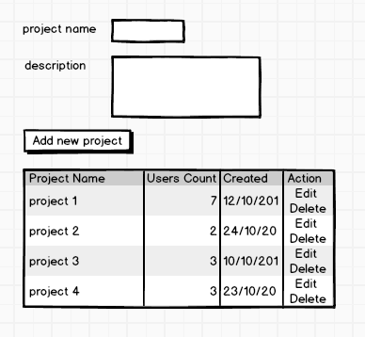

Side note: We expect to see how you can solve this problem, rather than how much you know the basics of .Net. Be creative, propose new ways to obtain the expected result. Use that design pattern that you love, create that infraestructure that was in your mind for months, chanllenge yourself to write small chunks of code lines. Surprise us..

